January 2017

Dear Colleague:

Harper College is pleased to invite you to “The Litrenta Triangle at Harper College” Novice Individual Events & Debate Tournament on Friday & Saturday, February 17 & 18.

A novice is a student with less than four full semesters of college competition experience. Students with junior/senior status CAN enter Reader’s Theatre, Parli, Public Debate (IPDA) and Group Communication.

We have made a number of changes to make things run smoothly, break as many students as possible, and end at a reasonable hour. Please read the invite carefully.

HOTEL

Country Inn & Suites
https://www.countryinns.com/schaumburg-hotel-il-60195/ilshburg

This is the official tournament hotel. We can only continue to get this fantastic rate if we USE the block. So please stay if you can. I spent a good deal of time finding a good deal and a nice hotel for us. I am confident that his hotel is the best deal in the area.

You are going to LOVE it! 5 minutes from Harper. You will have trouble finding a better price in this area. This hotel has a free SIT DOWN breakfast, business center, indoor pool, in-room coffee maker, fitness center, free happy hour, hair dryer, free parking, cookies and coffee all day AND free internet. Check out all the services.

Room Rate: $94

Reservations: 847-839-1010 and request their room reservation under the group block below..

Official Name of Group Block: "Harper College Speech Tournament"

Cut off Date: Feb 3

GENERAL INFORMATION

A novice is a student with less than four full semesters of college competition experience. Students with junior/senior status CAN enter Reader’s Theatre, Parli, Public Debate (IPDA) and Group Communication.

We will be using www.forensicstournament.net for Registration

We are pleased to once again be offering Group Communication. The “Group Com finalists” will NOT serve as the official judges for the STE final round this year. This event allows students to gain experience in small group work. The feedback from past years has been extremely positive. We hope that your students will give the event a try. If you have any group exercises that you believe would work well for this event, please forward them to me.

IE SCORING—same as 2016

IE Breaks- We will break all cumes of 6 (PRP Style). If that does not represent 20% of the field or 6 students we will break all cumes of 7 (and so on). In events in which more than 6 students break, we will hold multiple sections of finals for that event. We will use “prelim ranks + final round ranks (3 judges)” to determine silver/gold. “Next in” students will receive Bronze. For instance, if cumes of 7 break. All 8’s will be considered “next in.”
5 points Bronze
7.5 Silver
10 Gold

DEBATE SCORING—same as 2016

We are offering 4 preliminary rounds of both Parliamentary Debate and Public Debate (IPDA) and one final round.

The event of Group Com will be considered a Debate event, and therefore will count towards Debate Sweeps and Overall Sweeps, but not be counted in IE sweeps.

Debaters may not DE in the grouping in which they are debating.

Parli and Public Debate Breaks- All winning records (4-0 or 3-1) will advance to the Final round. We will use a 2-2/high-speaks records to fill out bracket if necessary. “Next in” debaters will earn Bronze. Finalists will earn Gold for a win and Silver for a loss.
5 points Bronze
7.5 Silver
10 Gold

AWARDS

Once again, we have teamed up with our Art Department to create our trophies. The student artists have been paid a stipend equal to what we would have spent on traditional trophies. The pieces are true works of art that I am confident your students will treasure.

GREEN TOURNAMENT

“The Litrenta Triangle at Harper College” is a Green Tournament. ForensicsTournament.net and www.harperspeech.net will allow us to post information/results online. We will also conserve paper wherever we can (half sheet size ballots, posting schematics instead of copying them, eliminating master ballots and printing back to back whenever possible). Look for a “green” slant in Extemp, Public Debate (IPDA), Parli & Impromptu.

Maps, Schedules, Restaurants, Schematics, Posting, Groupings, Adds, Drops and tournament information WILL NOT BE PRINTED. These Items will be available on your smart-phones, tablets and computer at ForensicsTournament.net & HarperSpeech.net the day prior to the tournament.

We WILL post these items for those participants without e-access. Stable Wi-Fi is available throughout campus.

Thanks for helping us keep this a green tournament ;-)

HARPER STUDENTS
Harper Students will be full tournament participants in Public Debate (IPDA), Parli and Reader’s Theatre. There will be a limited number Harper students entered in IE events, but will not be advanced to final rounds.

FOOD
Our all new Subway will be open 8am-3pm Friday.
Subway has taken over the space right in the center of our gathering space.

Harper will provide breakfast food and drinks Saturday morning. These Items will be limited because of the sit down breakfast at the hotel. We WILL have plenty of coffee throughout the day. We have made arrangements for that breakfast to begin on Saturday morning at 6 AM.

On Saturday, Subway will NO BE OPEN.

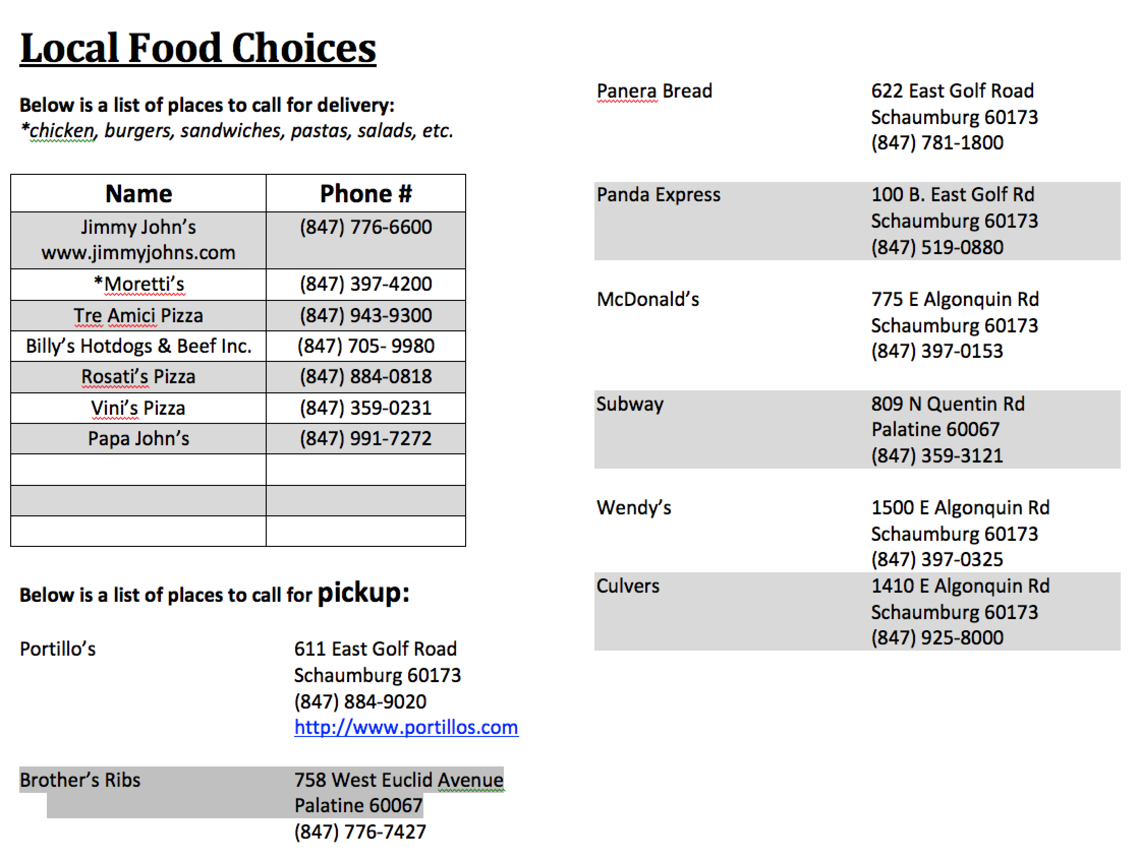

EXTEMP
Round one of extemporaneous speaking will focus on local Illinois issues. Round two will focus on national issues. Round three will focus on international issues. The final will focus on Multi-Party issues.

SWEEPS
We will award top 3 IE Teams (Group is NOT an IE event)
We will award top 3 Debate (Parli, IPDA & Group) Teams
We will award top 6 Overall Sweeps Teams

FEES
$8.00 per IE slot
$16 per Parli team (was $25 Last Year)
$16 per Public Debate (IPDA) team (was $25 Last Year)

$10.00 per slot not covered by a judge
$50.00 per debate slot not covered by a judge-- We need your judges, not your money.

GROUPINGS
Group A | Group B | Group C
Prose Reading | Persuasive Speaking | Reader’s Theatre
Poetry Reading | STE | POI
Extemp* | Duo Interpretation | DI
Group Communication* | Communication Analysis | Informative Speaking
Impromptu | Public Debate IPDA (4 rounds)** | Parli Debate (4 rounds)***

ENTRY LIMITATIONS - PLEASE LOOK AT THIS SECTION CAREFULLY!!!

Students may enter 2 events per group

Schools may have as many as 8 of each event.

*Students may NOT DE in Group and Extemp because these events occur simultaneously.

**Public Debate (IPDA) can be a student’s ONLY event in group B.
***Parli can be a student’s ONLY event in group C.

SCHEDULE same as 2016

Friday
10:30-11:45 IE & Debate Registration
The Avante’ Center Hallway (Building Z). Park in lot #3.

11:45 Extemp Prep and Group Communication Round I
12:15 Round IA
1:15 Extemp Prep and Group Communication Round II
1:45 Round IIA
2:45 Extemp Prep and Group Communication Round III
3:15 Round IIIA

3:15 Registration for Debate only teams

Public Debate (IPDA) Students—For Public Debate (IPDA) to run on time, competitors must return to prep immediately after their round. We will NOT do common draw. You will draw as soon as both debaters are present. In Public Debate (IPDA) we are going to do 25 minutes of prep instead of 30.

4:15 Round IB & Public Debate (IPDA) Round 1 (Draw-4:15 / Speak-4:40)
5:15 Round IIB& Public Debate (IPDA) Round 2 (Draw-5:15 / Speak-5:40)
6:15 Rounds IIIB & Public Debate (IPDA) Round 3 (Draw-6:15 / Speak-6:40)
7:15 Public Debate (IPDA) Round 4 (Draw-7:15 / Speak-7:40)

Saturday
8:00 Round IC & Parli Round 1
9:15 Round IIC & Parli Round 2
10:30 Round IIIC & Parli Round 3

LUNCH

11:45 Parli Round 4
Lunch

1:00 Draw for Ext & Group Com Discussion (Group final)

1:15 Group A finals *Any student in Group will arrive 30 minutes after the final round has begun

1:30 Extemp Final
2:30 Group B
Public Debate (IPDA) Finals--- Draw 2:30 Speak 2:55

3:45 Group C & Parli Finals

ASAP Awards

JUDGES
1 Judge will cover 6 IE slots
1 Judge will cover 4 debate slots if they commit to judging BOTH Parli and Public Debate
1 Judge will cover 2 debate slots if they commit to judging ONLY Parli or Public Debate
1 Judge can cover 2 debate slots AND 3 IE slots
* If you are using judges to count for some ie and debate, the online program will estimate your bill incorrectly. We will have revised bills when you arrive.

We need your judges, not your money.

IE judges may be assigned a Parli round or 2 if needed. Jeff will check with you first.
IE judges WILL judge some Public Debate (IPDA). “Lay Judges” are central to this form of debate.

REGISTRATION
Register your entry by Tuesday at 7pm at Forensicstournament.net

Please make checks payable to Jeff Przybylo NOT Harper College.

DROPS
Drops after Thursday at 12:00 PM-$15.00 per slot.
Drops from the van Friday morning- $15.00 per slot
Please text or call drops to Jeff at 847-567-2525 as soon as you know about them.
Drops at registration- $50.00 per slot.
With the wide spread use of cell phones, drops at registration are unnecessary.
A dropped judge at registration will be $60.00.

GROUP COMMUNICATION

5-6 students will be placed in each round. The group will be given 35 minutes to complete a problems-solving or decision-making activity. Topics will be different from round to round. Students will be given traditional group communication activities or current events oriented discussion topics (How should the USA deal with…).

One judge will observe the group and rank the participants first through forth. Ranks will be based on group communication concepts such as leadership, verbal communication, non-verbal communication, listening skills, goal setting, conflict resolution, setting criteria for solvency, and argumentation. There will be three rounds and a final. A Group Communication student may not enter Extemp.

FINAL - The “Group Com finalists” will NOT serve as the official judges for the STE final round this year. The Group Com finalists’ will INSTEAD be given a problem to solve/discuss. The group discussion will be observed by 3-5 judges. They will rank the Group Com finalists. At the conclusion of the student discussion, the judges should take 10 minutes to discuss their feelings about the round. They should, however, rank the round independently. Audience members will be dismissed before the judge discussion.

Group Com points will be considered for Debate Sweeps and Overall Sweeps. NOT IE.

Jeff Przybylo-Director Margaret Bilos- Assistant Director Josh Sunderbruch-- Debate Coach
Cell: (847) 567-2512 Cell: 773-456-7696 Office: 847-925-6618

